**D.K. GOVT.COLLEGE FOR WOMEN (A) NELLORE**

**DEPARTMENT OF COMMERCE**

**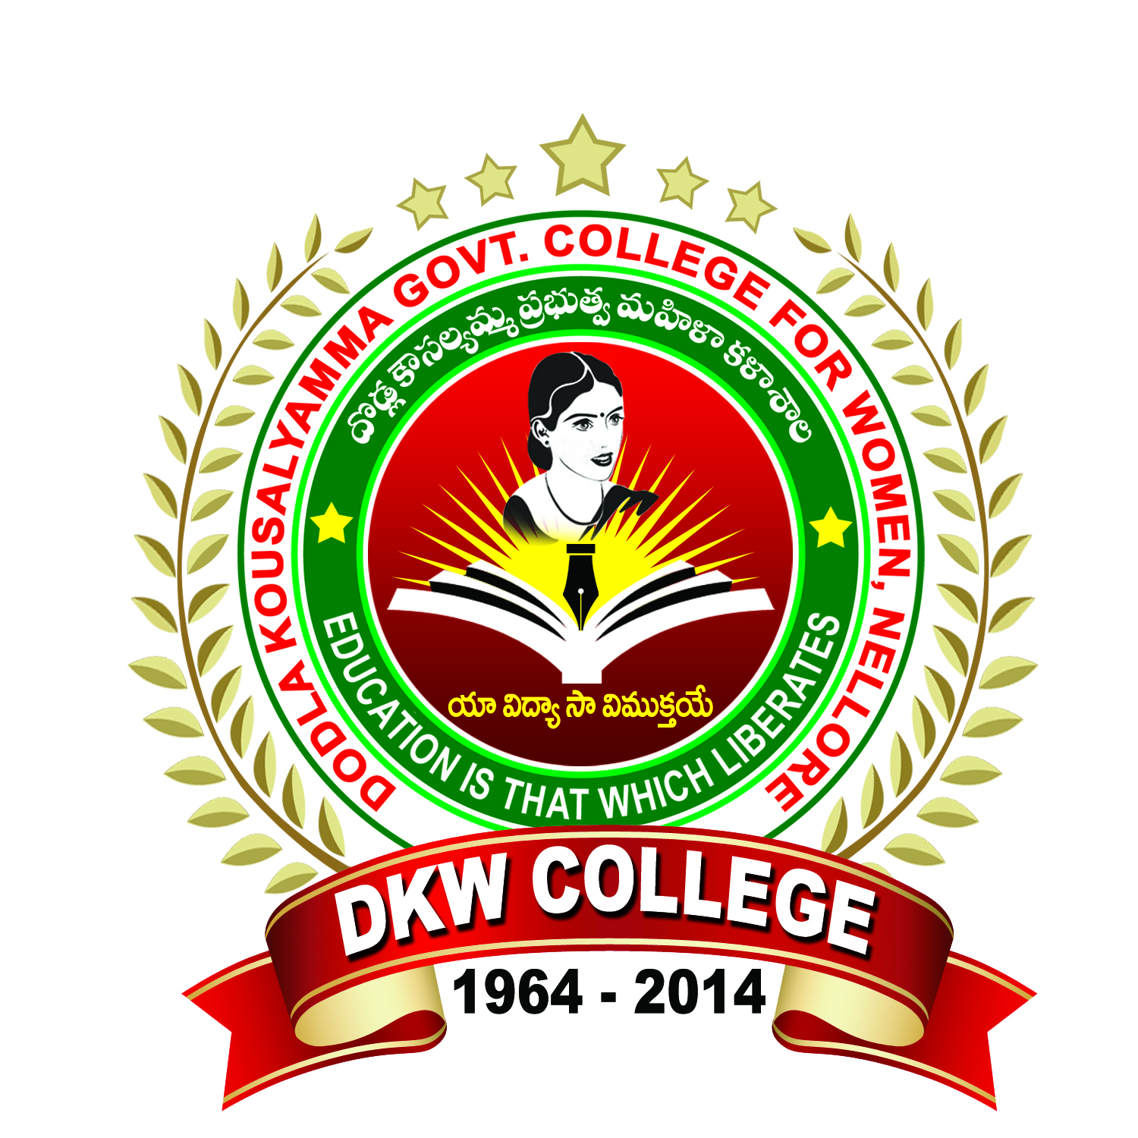  
PERSONAL PROFILE**

**Mr. M.Premananda Babu, M.Com**

**FACULTY IN COMMERCE**

**PERFORMANCE APPRAISAL-INDIVIDUAL**

**Performance Appraisal Report Self Appraisal**

1. **GENERAL INFORMATION:**
2. Name : M.PREMANANDA BABU
3. Date of Birth : 20/07/1976
4. Mailing Address :Department of Commerce

**D.K. Govt. College for Women, Nellore SPSR Nellore (DT).**

1. Permanent Address : VEGUR VILLAGE & POST

KOVUR MANDAL,

S.P.S.R. Nellore (District) PIN-524137

1. Designation : Guest Lecturer in Commerce
2. Department : Commerce
3. Area of Specialization :
4. Date of Appointment : 21/07/2015

1. **ACADEMIC QUALIFICATIONS :**

|  |  |  |  |  |
| --- | --- | --- | --- | --- |
| **Exam Passed** | **University** | **Subject** | **Year** | **Division** |
| M.Com | **S.V University**  **Thirupati** | Commerce | 1999-2001 | II |

1. **RESEARCH EXPERIENCE AND TRAINING :**

|  |  |  |
| --- | --- | --- |
| **Research Stage** | **Title Of The Work/ Thesis** | **University Where The Work Was Carried Out** |
| **--** | **--** | **--** |

1. **Work Experience :**

|  |  |  |
| --- | --- | --- |
| **Course Taught** | **Name of the University/College/ Institution** | **Duration** |
| Under Graduation | PRR &VS Govt. Degree College, Vidavaluru | 2010 -11 to 2014-15 |
| D.K. Govt. College For Women(A), Nellore | 2015-16 to till date |

1. **Total Teaching Experience :**

UG level - 12 Years

1. **Improvement of Professional Competence:**
2. Details of Refresher/Orientation Courses attended Shown in

Participation in summer institute, winter institute Annexure – III a

Workshops, seminars, symposia etc

1. **Details Of Innovations / Contribution In Teaching :**
2. Evaluation Methods : Discussions, Seminars, Tests & Quiz Programmes
3. Remedial Teaching/ Student Counseling(Academic) : Taken Bridge Course / Remedial Classes and student Counseling Classes at Various Levels
4. **Details of participation in the following:**
5. University evaluation : examiner for VSU examinations
6. Contribution to university :
7. Paper setting : various autonomous colleges
8. **Membership with professional bodies:**
9. **Extension work :**
10. **participation in bodies of education :**

**Research Publications**

|  |  |  |  |
| --- | --- | --- | --- |
| **Sl. No** | **Title** | **Author** | **Year** |
| -- | -- | **--** | -- |

**Conferences, symposia, workshops, training programmes attended**

|  |  |  |  |  |  |
| --- | --- | --- | --- | --- | --- |
| **Regional** | **State level** | **National level** | **International level** | **Workshops** | **FDP** |
| **01** | **00** | **05** | **00** | **02** | **01** |

**Conferences Organized**

|  |  |  |  |  |
| --- | --- | --- | --- | --- |
| **Regional** | **State level** | **National level** | **International level** | **Workshops** |
| **--** | **--** | **--** | **--** | **--** |

**Community Services:**

Actively conducted consumer’s day celebration and make awareness of consumers about the goods. Participated in the AIDS awareness programmes organized by the NSS unit and Red Ribbon Club of our college and participated in the Rally and create awareness among the students and people of Nellore town. Participated in the HAR GHAR THIRANGA rally to create national integrity among the students.

Participated in the Swatch Bharath and Clean and Green Programme held in the College campus..

Sri. M.Premananda Babu

Mobile No: 9966119104

Email id: [mpremanandababu@gmail.com](mailto:mpremanandababu@gmail.com)